Resume

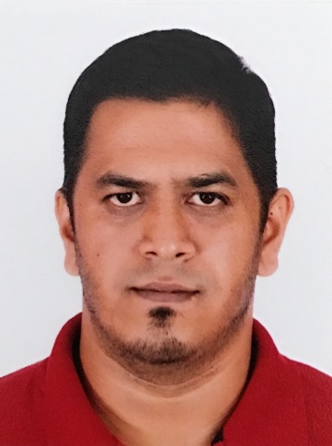

Full Name: Haque Khandoker Mohd Mazidul

Phone Number: 01042018399 | Email: tebunia@gmail.com | GitHub: https://github.com/jibonaronno | Current Location: Incheon

Nationality: Bangladeshi | Visa Status: E-7-1

**Professional Summary**

Capable of operating CNC machines, Maintain and tech support for any type of Electrical and Electronic circuit devices. Maintain and Troubleshoot CNC machines.

Experienced CAD Designer and Embedded Firmware Developer with over 10 years of expertise, including 2.5 years in South Korea. Proven skills in embedded systems design, STM32 and AM5718 microcontrollers, Embedded Linux, and industrial communication protocols such as Modbus TCP and CAN Bus. Strong hands-on experience in NXP i.MX8 and Rockchip-based platforms, stepper motor controllers, and real-time systems. Seeking opportunities in a dynamic working environment in Korea.

**Technical Skills**

1. Provided CNC Training to Agriculture Universities in Bangladesh.
2. Repair and Maintain CNC Machines in Energypac Engineering Ltd.
3. Operated HAAS CNC Machines in Energypac Engineering Ltd.
4. GCode Experiences.
5. Communication: CAN Bus, Modbus TCP, UART, SPI, I2C, Ethernet
6. Motion Control: Stepper Motor, BLDC Motor, Servo Motor & Controllers

**Professional Experience**

**Senior Researcher**

**Sanion Co (www.sanion.com), South Korea**

March 2023 - Present

• Developed and maintained firmware for STM32 and AM5178-based industrial controllers.

• Designed 6-layer PCBs for a Flight Controller sensor board.

• Implemented Modbus TCP/IP protocol stack and CAN bus diagnostics module.

• Led stepper motor controller development for automation systems.

• Worked with Yocto-based Linux systems.

• Build Embedded Linux Firmware to collect High Density data from 50 types of sensors.

**Embedded Systems Developer**

**Energypac Engineering Ltd (www.energypac.com.bd), Bangladesh**

2014 – 2022

• Maintain, Repair and Program Various CNC Machines.

• PLC Program

• Contributed to firmware for sensor integration, motor control, and HMI systems.

• Collaborated with hardware teams to debug board bring-up issues.

**Projects**

• Industrial Stepper Motor Controller

• CNC Machine Modbus Interface with PC.

• Integrated PID control, encoder feedback, and overcurrent protection.

• Outdoor Cabinet Ventilation Controller.

• Educational Robots for kids.

Languages

English – Professional

Korean – Basic

E-7-1 Holder | Familiar with Korean corporate culture | Available for full-time roles